NATURAL LANGUAGE PROCESSESING

NAME: MOHAMMAD SHAHIL HUSSAIN REG NO: 19BCE2447

DATE: 7/15/2022

1. Encoding

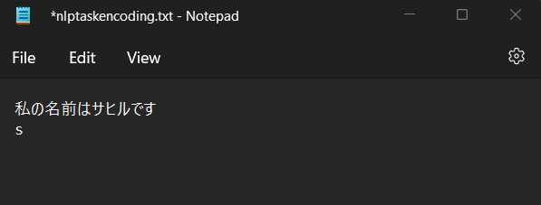

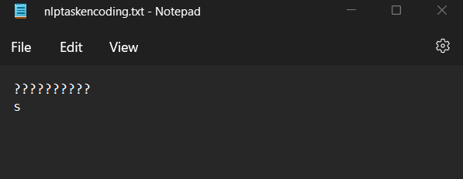

1. COCA

Mukesh ambani

from the graph we can understand that Mukesh ambani was most relevent form 2000 till 2014, he stayed the almost same popularity for those years consisitantly. he was in the following sections WEB(FREQ-6, WORDS(M) - 124.3), MAG(FREQ - 1, WORDS (M)-126.01), NEWS(FREQ- 4, WORDS (9)- 121.7). For all these section he has a frequency of 12 and words (M) of 993.

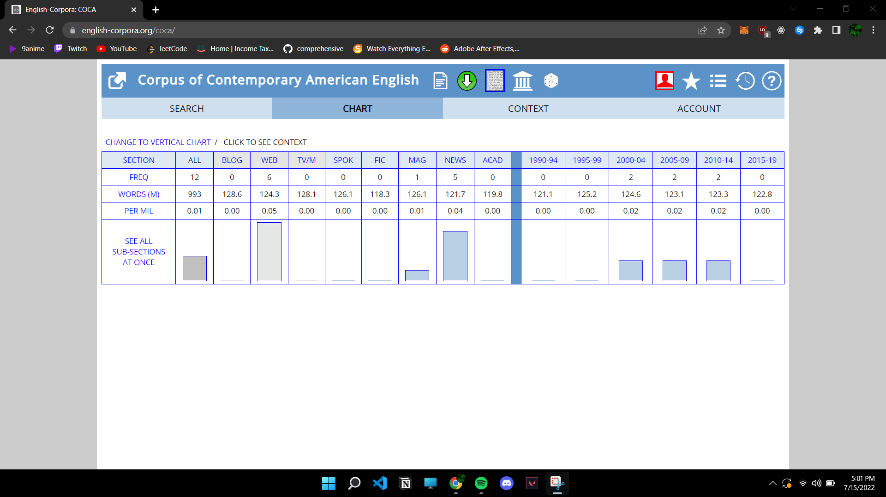

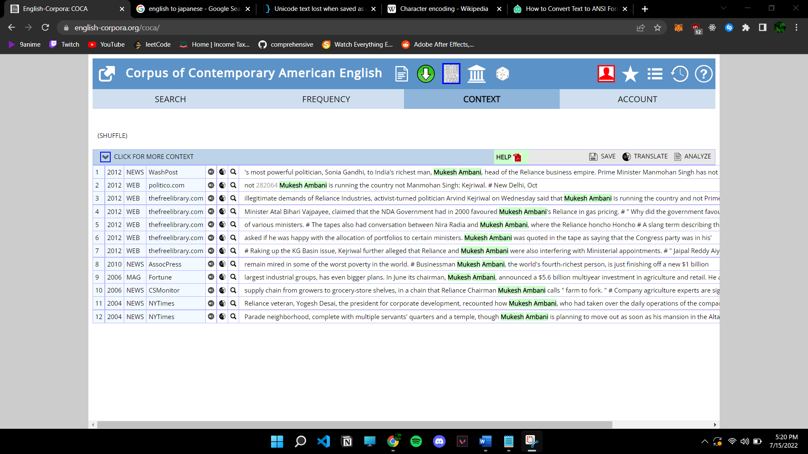

1. Read book & 4. frequency

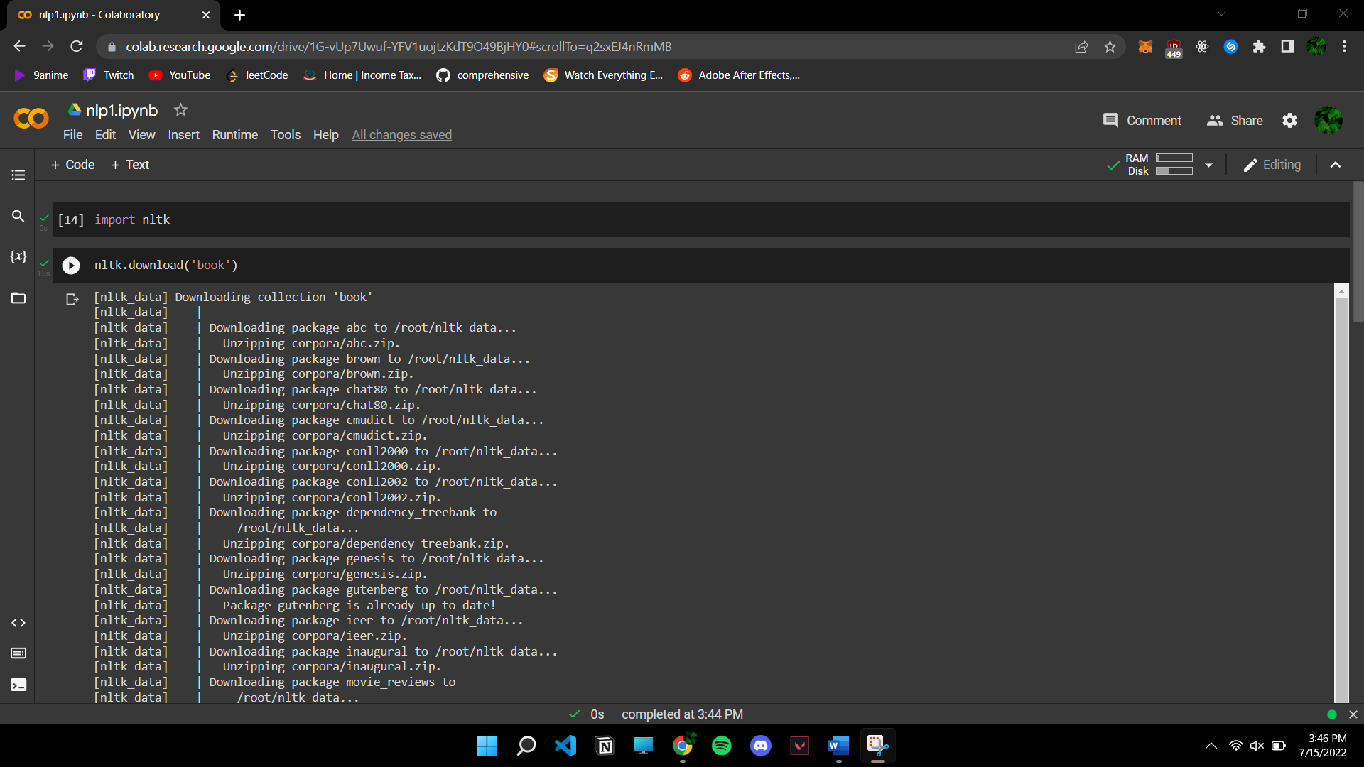

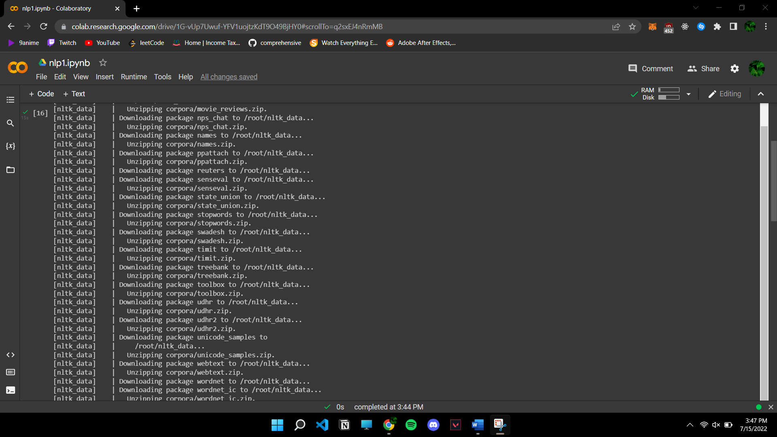

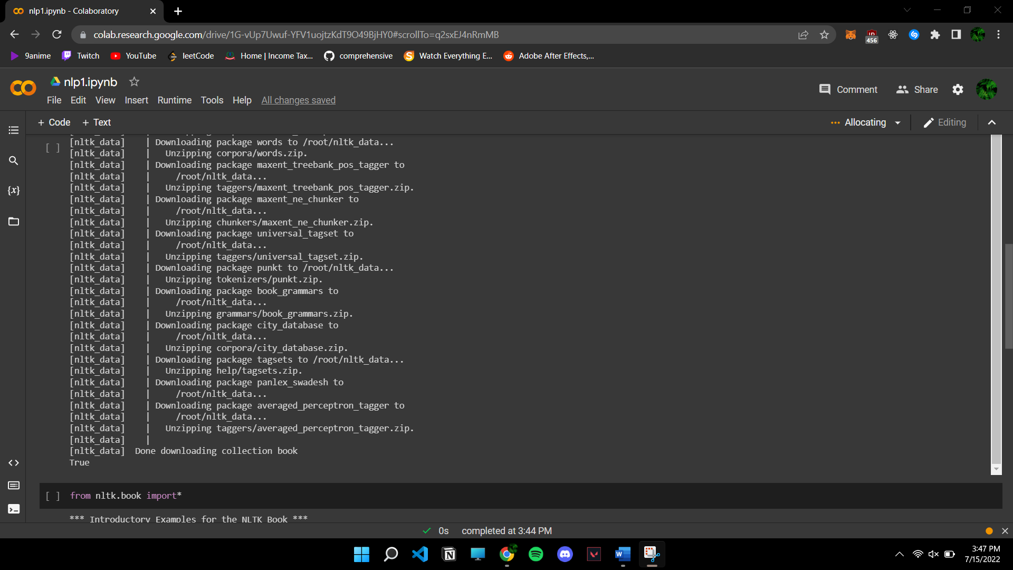

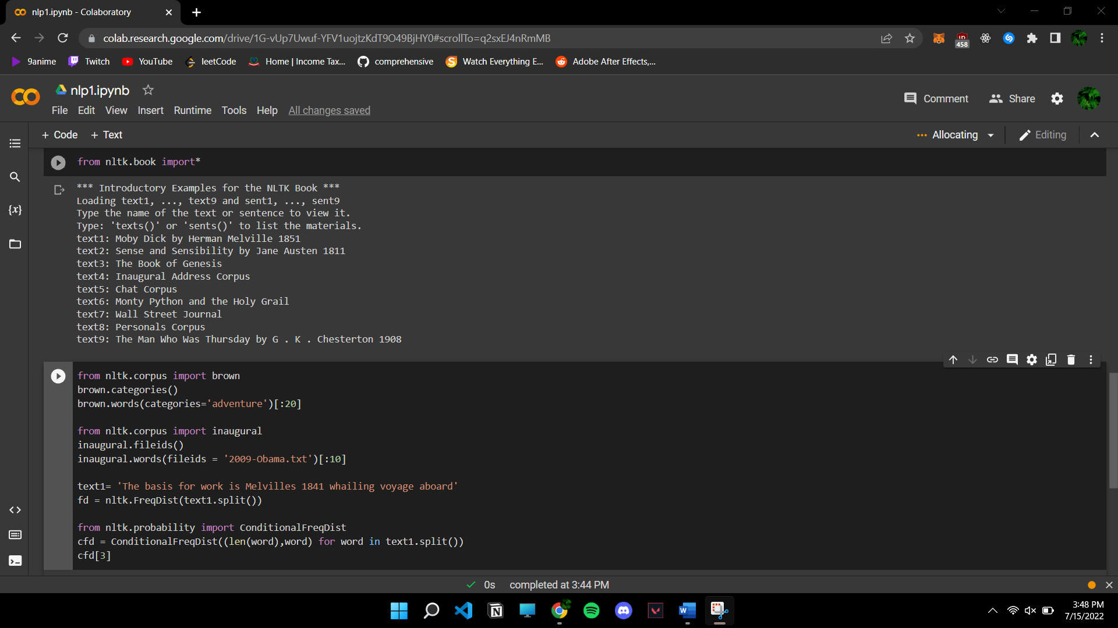

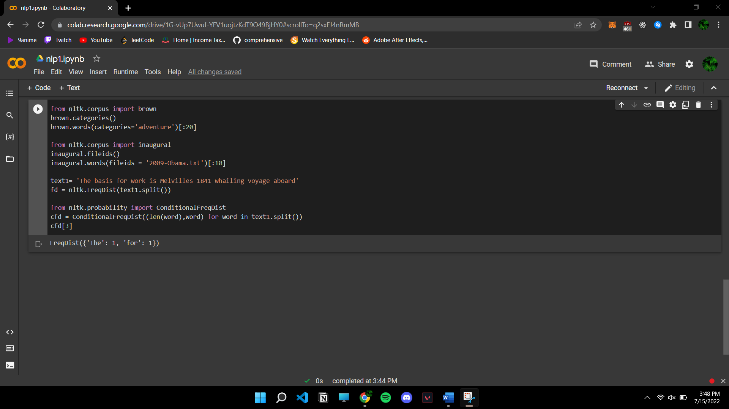

1. Application of CORPUS

***Classroom applications of corpus analysis***



Corpora have found many uses in the field of language teaching and learning in the hands of

decision-makers, teachers and learners. Published research covers classroom applications

for a wide variety of learner profiles and for extremely different uses, from highly controlled

to entirely autonomous work, from paper-based materials to hands-on concordancing, from

reference resource to learning tool. This variety underlines the highly flexible role of corpora

– there is no single ‘right’ way to use them. From a research perspective, this may lead to a

perceived fragmentation of the field, which a thorough meta-analysis may go some way to

resolving.

In the hands of decision-makers, teachers, and students, corpora have found many applications in the field of language teaching and learning. Published research includes a wide range of learner profiles and uses for classroom applications, including highly controlled and completely independent work, hands-on concordance and reference resources as well as learning tools. This diversity highlights the fact that corpora have a very flexible role and that there is no one "correct" way to use them. A detailed meta-analysis may help to some extent in reconciling the perceived fragmentation of the area from the perspective of research.